**How to Build the Dementia Friendly Music Player**

19 December 2019, <http://DementiaMusicPlayer.org>, Ross Porter [rosswesleyporter@gmail.com](mailto:rosswesleyporter@gmail.com)

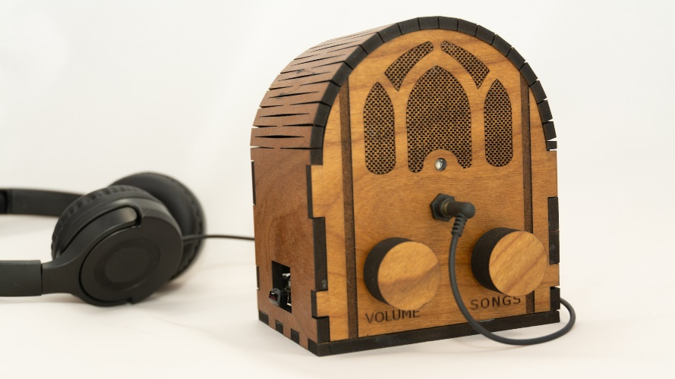  
  
My Dad could not operate normal music players. But he could operate this music player because it operates like a familiar two-knob radio. My son & I were inspired to design this by the documentary [Alive Inside](http://www.aliveinside.us/#land) which shows the profound joy felt by some people with dementia when listening to their favorite music.

It’s easier than you think to make one. Everything I did (e.g. software, wood case design) is open source. This document contains all the information you need. You can order the parts online. Good project for kids. A 13 year old can do this with minimal assistance. Younger kids with more assistance.



|  |  |
| --- | --- |
| **Parts cost** | ~$110 + tax + shipping |
| **Music cost** | Minimal as you should use the recipient’s existing music collection |
| **Build time** | About three hours, once you have the parts & music |
| **Parts source** | All parts can be mail ordered, links below |
| **Soldering?** | No |
| **Woodworking?** | No |
| **Laser cutter needed?** | No, you can mail order the pre-cut pieces for the wood case |
| **With a friend?** | Good idea, especially if your friend has the basic tools required |
| **Beverage?** | I recommend a hoppy IPA while you are assembling |

|  |  |
| --- | --- |
|  |  |

# Preview of the steps

|  |  |  |
| --- | --- | --- |
| **STEP 1: Order parts** | **STEP 2: Assemble recipient’s favorite music**  Complete Beethoven Edition, Vol. 1: Symphonies | **STEP 3: Copy software to micro SD card**  http://ecx.images-amazon.com/images/I/71sgCaQGpKL._SL1500_.jpg |
| **STEP 4: Stain it** | **STEP 5: Add the Pi** | **STEP 6: Wire it** |
| **STEP 7: Glue it** | **STEP 8: Add audio cable** | **STEP 9: Enjoy!** |

# No warranty

USE THESE DQMUSICBOX PLANS AND SYSTEM AT YOUR OWN RISK. THE DQMUSICBOX PLANS ARE PROVIDED AS IS WITHOUT WARRANTY OF ANY KIND EITHER EXPRESSED OR IMPLIED, INCLUDING, BUT NOT LIMITED TO, THE IMPLIED WARRANTIES OF MERCHANTABILITY AND FITNESS FOR A PARTICULAR PURPOSE. THE ENTIRE RISK AS TO THE QUALITY AND PERFORMANCE OF THE PLANS AND SYSTEM IS WITH YOU. SHOULD THE PLANS OR SYSTEM PROVE DEFECTIVE, YOU ASSUME THE COST OF ALL NECESSARY SERVICING, REPAIR OR CORRECTION. IN NO EVENT WILL ANY PARTY BE LIABLE TO YOU FOR DAMAGES, INCLUDING ANY GENERAL, SPECIAL, INCIDENTAL OR CONSEQUENTIAL DAMAGES ARISING OUT OF THE USE OR INABILITY TO USE THE PLANS OR SYSTEM.

# Acknowledgements

People were very generous with their time, and I really enjoyed the experience. This is certainly an incomplete list: Alex & Mike & others at [Ada’s](http://blog.seattletechnicalbooks.com/), the super smart staff at [Metrix](http://www.metrixcreatespace.com/), neighbor Randy, [Stephen Christopher Phillips](http://scphillips.com/), [Bob Rathbone](http://www.bobrathbone.com/), [Stephen Rusk](http://www.stephenrusk.com/), [Graham Hill](http://www.ted.com/speakers/graham_hill), support at [Ponoko](https://www.ponoko.com/), [Florian Festi](https://www.festi.info/boxes.py/index.html), and my son.

# What DQMusicBox does

## For the person with dementia

|  |  |
| --- | --- |
| **Name** | **Description & implementation** |
| Start song | Turning either of the knobs will start music playing. |
| Change song | Turn the songs knob. |
| Change volume | Turn the volume knob. |
| Pause | Tap the volume knob. Note that this also happens automatically – music pauses if there are no knob events in one hour. |

## For you

|  |  |
| --- | --- |
| **Name** | **Description & implementation** |
| Shut down | Pull the power plug or long hold (15-30 seconds) on the volume knob. |
| Reboot | Pull the power plug and re-insert or long hold (15-30 seconds) on the songs knob. |
| Add/remove music | By adding/removing files on the USB memory stick. |

# STEP 1: Order the parts

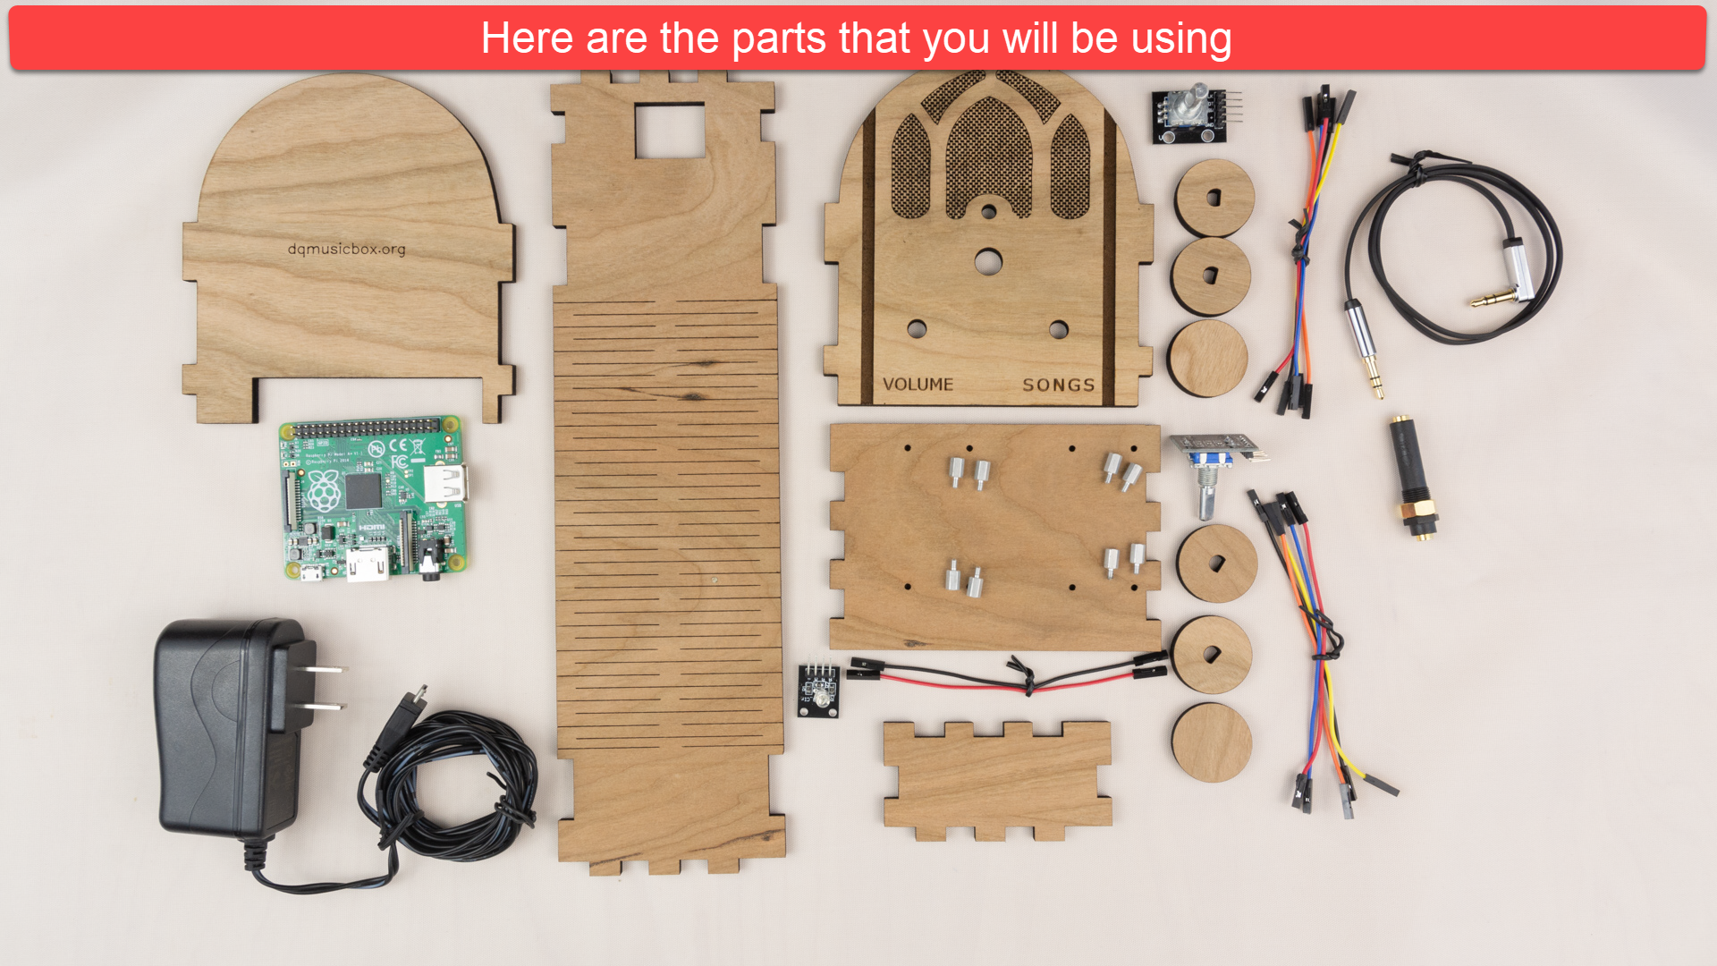

## Create a Ponoko account (optional but convenient)

Ponoko is a company that laser cuts wood and sends you the precisely cut pieces. You don’t need to use Ponoko – you are welcome to download my case design files (from [Ponoko](https://www.ponoko.com/design-your-own/products/case-for-dementia-friendly-music-player-with-speakers-15223) or [github](https://github.com/rosswesleyporter/dqmusicbox/tree/master/case/laser_cut/cherry_with_small_speakers)) and go to your local maker space and use the laser cutter there. Or buy yourself a laser cutter (if you do, will you be my friend?). In other words, Ponoko is convenient but not necessary. I have no affiliation with them, other than being a happy customer. To create a Ponoko account:

1. Go to <https://www.ponoko.com/>
2. Choose “Get Making”

## Order from Ponoko

1. Go to <https://github.com/rosswesleyporter/dqmusicbox/tree/master/case/laser_cut/cherry_cathedral_style>
2. Right-click on DQMusicBox_cathedral_5point7mm_cherry.svg, choose to “Save link as…”
3. Verify that you chose the correct file – has 5poin7mm in the name and is a .svg file.
4. Go to <https://www.ponoko.com/>
5. Login
6. If prompted in blue at the top of the screen, choose to switch to Ponoko 5.0
7. Choose “Make your custom parts”
8. Choose “Upload your design” and upload the file that you downloaded just above
9. Set the design colors as per below:  
   
10. Choose “Confirm design size & colors”
11. Choose wood = “Cherry Veneer MDF”, confirm thickness = 5.7mm, click “Confirm material”  
    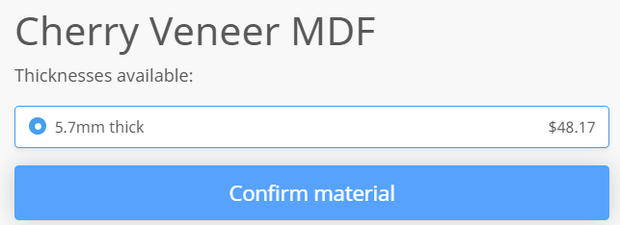
12. Make sure that everything looks as expected especially the check that the horizontal bar above SONGS is colored in  
    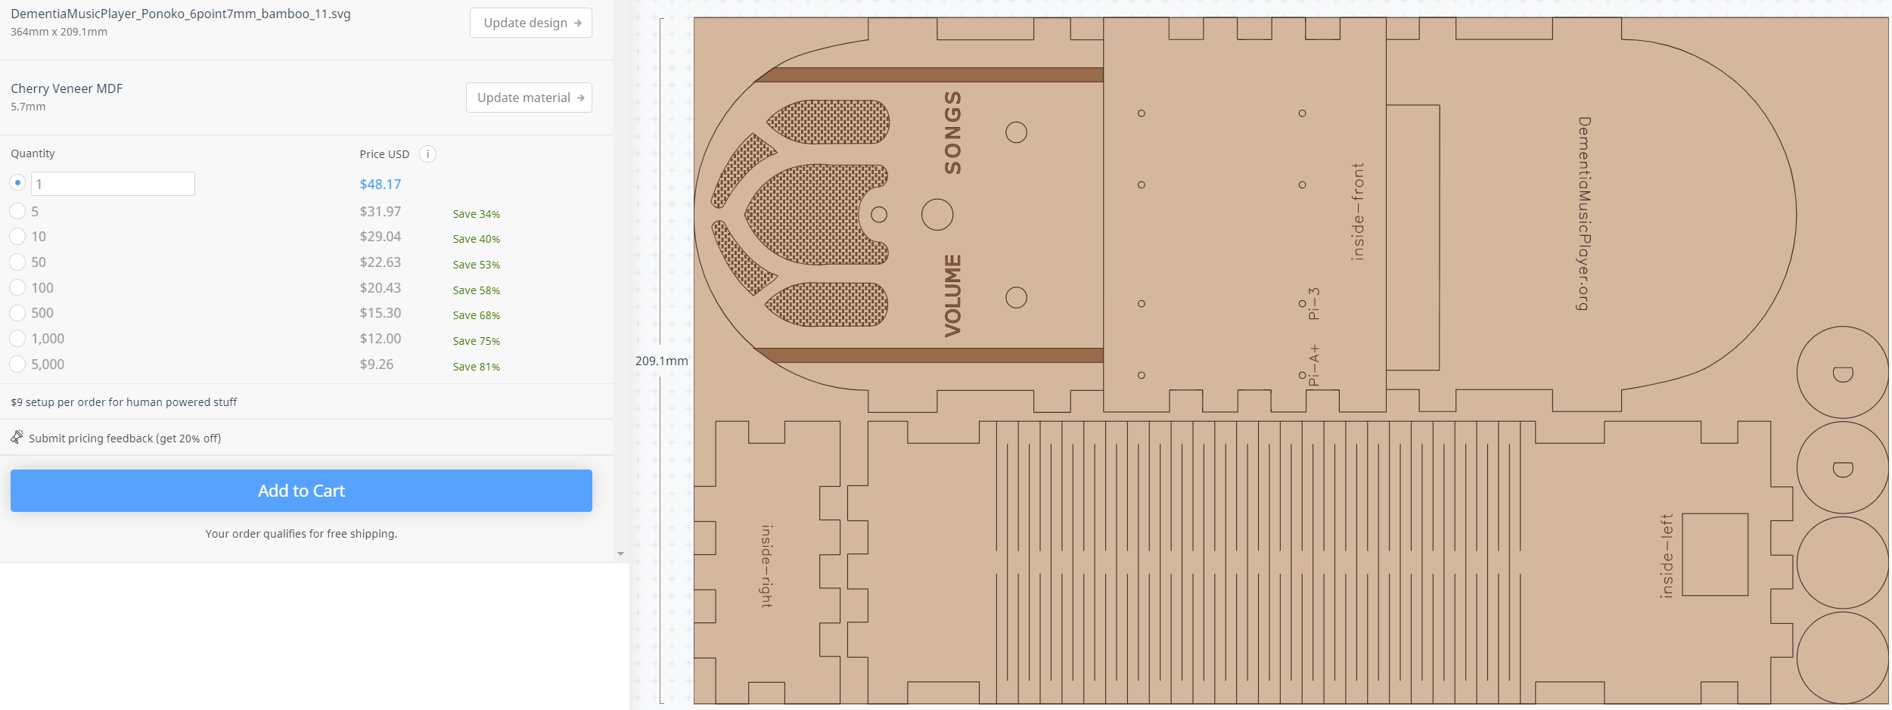
13. Click “Add to Cart”

## Order the remaining parts

|  |  |  |  |
| --- | --- | --- | --- |
| **Item** | **Supplier** | **Cost** | **Notes & alternatives** |
| Cherry case | Ponoko | $48.17 | See instructions above. |
| [Raspberry Pi 1 A+ single board computer](http://www.newark.com/raspberry-pi/raspbrry-moda-512m/silicon-manufacturer-broadcom/dp/81Y5333) | Newark | $20.00 | Or upgrade to [Pi 3A+](https://www.newark.com/raspberry-pi/rpi3-modap/dev-board-64-bit-1-4ghz-cortex/dp/80AC9303?pf=815332049&krypto=ODn0gLn1GBivLDf6gviHGy2OuVmW01yrm5xJv3A8eORTGfdZdtNpNcgLml7YjFhiZSckCHKqaqw50MAQKUAZNKzSmtUFYhAVnxHqBQsOHlBF%2BOXIkEfuE3PpXrDVoSXTeqWH%2FFGSkAv9RUP6OFjPwH04aeBaB%2Br9Wp48pYeu6cQvGvROTPNpk8W7yhRevgfWdFRI6jvr55UoscXyKJiULix%2BIsLSxnpytBRvplEpqNQnZiLheMcMiFAYEisJ8mfBu9Gbf6x3ZRzdOhwYMA45DrKKtGwf4BYtrBxdc7C9gSJo21Wl6OYr%2BxpK5xQVK%2BXN7YDTzG73iZvJAQJ44dSZQJUEHGLsy9MlujSpKIv3oI6BZwcztyMOkIOLo2C%2FiOhUg%2FTWqL5aRbnK8GDM7fBc%2FGmyNsI1dLKgcTE5zAuCuwx3IR335MhELScOFVJn2SYTmxyFgomuh9sWnuTDxRCC%2FpIpQLvcbGLKrCeYIHdNE9cm8vttsodvOq3lhEWuQktXQ6ynw6NcBo3CNkOIQnE80NTDgIxe2lY%2BxR%2BEYYJDY3ihe3bHmmpQC1OenBz44mlGJZBvpLZ8hYgMlOD27NGUFPZ62qhsWY2hoVMKTZ%2F05meWcgJahd%2FTQbs04lW6llnKOwLHZcMy%2BQdBStw9O5qm%2FHrIpWxWzx1tdJxPdZGThh1f1AwkTnV8M6eYXxgVZr1pNygXtdtdN40foaJfnlf3cQjd5bJqlh%2B18qwS1OJ%2F96xpSFP9%2Bo8dro%2FNfnCxxTUOeWQpx7RFgcxPvezL4fex9r7kgRatcZEVvrtFO8A%2BcdC2OpKT3NoWVFFyKBk9ez3job8lJbCgUSRo66uZDvHNXfAwABpXwixAJfELyhaADD2VFfFBDzr4qKQjA7oDRUK6PAvKYO4Q0uUIsbiGKEZArjVIXWHzkHqlKKzC%2FATZBC9Go72HHwInBOwWSi%2FHVe7C2TdjJrxikUbtF351q5ZrPJWpJv1rhbEY0SFItthqJpSn5WBow%2BhTn7tfJbRdhflf2ui6Yq72xEammedWAYXMxkOzl0vlitRcYpQ7gvZkpJmibNfmZT%2FQd1aa6c4%2F%2FDpiwTFnJFzJmVZlDuYz01MQdXpLEm2L0%2FN%2FN8fMwYt4ByfRnd52UJezSOuU4KUw5BUjJzAqvsnLcDToR0YWBZco8Mho%2BPiiPlmaxvvNFeoigeSNaVu%2BMxYqOkeefKBi53YN&ddkey=https%3Aen-US%2FElement14_US%2Fc%2Fembedded-computers-education-maker-boards%2Fraspberry-pi%2Fembedded-single-board-computers-sbc-raspberry-pi). Also tested with a 2B, 3A+, 3B, 3B+, 4B. Do not use Pi Zero. |
| [Power supply](http://www.mcmelectronics.com/product/28-19338) | Newark | $3.62 | Or Newark [T5582DV](https://www.newark.com/stontronics/t5582dv/psu-raspberry-pi-5v-2a-micro-usb/dp/64X7261). Or order one for your region/plug. Any micro USB 2A supply will do. |
| [Female-female jumper wires](http://www.newark.com/adafruit/266/female-to-female-jumper-wires/dp/42X1200) | Newark | $3.95 | Or buy Amazon [B01L5ULRUA](https://www.amazon.com/GenBasic-Female-Solderless-Breadboard-Prototyping/dp/B01L5ULRUA/ref=sr_1_3?s=electronics&ie=UTF8&qid=1524365861&sr=1-3&keywords=female+female+jumper+wires) |
| [Panel mount 3.5mm headphone jack](http://www.newark.com/mcm/27-5937/3-5mm-inline-stereo-mount-female/dp/40T6284) | Newark | $2.69 | Or buy Amazon [B004JX64FE](https://www.amazon.com/3-5mm-Stereo-Feed-Thru-Panel-Mount/dp/B004JX64FE/ref=sr_1_1?s=electronics&ie=UTF8&qid=1508035643&sr=1-1&keywords=B004JX64FE) |
| [M2.5 standoffs (screws) – 8 of them](https://www.newark.com/raf-electronic-hardware/m2102-2545-al/spacer-standoff-hex-aluminium/dp/27T7975?st=M2.5%20standoff) | Newark | $4.32 | Or by Amazon [B06XXV8RTR](https://www.amazon.com/eBoot-Pieces-Female-Standoff-Assortment/dp/B06XXV8RTR/ref=sr_1_1?s=electronics&ie=UTF8&qid=1508035656&sr=8-1&keywords=B06XXV8RTR) |
| [Micro SD card](https://www.amazon.com/gp/product/B079H6PDCK/ref=ox_sc_saved_title_1?smid=ATVPDKIKX0DER&psc=1) | Amazon | $3.99 | Or upgrade to Amazon [B06XWN9Q99](https://www.amazon.com/gp/product/B06XWN9Q99/ref=ox_sc_saved_title_2?smid=ATVPDKIKX0DER&psc=1). Any brand name card that is 16GB or larger will do. |
| [USB thumb drive](https://www.amazon.com/SanDisk-16GB-Cruzer-Flash-Drive/dp/B07MDXBT87/ref=sr_1_10?keywords=Cruzer+8GB&qid=1572121525&s=electronics&sr=1-10) | Amazon | $5.79 | This one is helpfully physically small, but many USB drives will work. Or Amazon [B077Y149DL](https://www.amazon.com/gp/product/B077Y149DL/ref=ox_sc_saved_title_10?smid=ATVPDKIKX0DER&psc=1). |
| [Audio cable](https://www.amazon.com/gp/product/B00LM0U8I6/ref=oh_aui_detailpage_o00_s00?ie=UTF8&psc=1) | Amazon | $5.79 | Or Amazon [B00SUIKMJ8](https://www.amazon.com/dp/B00SUIKMJ8/ref=twister_B07Q4W92M7?_encoding=UTF8&psc=1). Or find a short audio cable with a right angle bend. |
| [KY-016 indicator LED](https://www.amazon.com/KY-016-Colors-Sensor-Arduino-Starter/dp/B0786CQD5P/ref=sr_1_1?keywords=KY-016&qid=1572122200&sr=8-1) | Amazon | $6.99 | Or buy Amazon [B07KJYR8K1](https://www.amazon.com/Aokin-Sensor-Module-Arduino-Raspberry/dp/B07KJYR8K1/ref=sr_1_5?keywords=KY-016&qid=1572135296&refinements=p_85%3A2470955011&rnid=2470954011&rps=1&sr=8-5). Or search Amazon for KY-016. |
| [KY-040 rotary encoders (knobs)](https://www.amazon.com/Tegg-KY-040-Encoder-clickable-Arduino/dp/B07QL6V4WP/ref=sr_1_11?keywords=KY-040&qid=1572122001&sr=8-11) | Amazon | $7.99 | Or buy Amazon [B06XQTHDRR](https://www.amazon.com/Cylewet-Encoder-15%C3%9716-5-Arduino-CYT1062/dp/B06XQTHDRR/ref=sxts_sxwds-bia?keywords=KY-040&pd_rd_i=B06XQTHDRR&pd_rd_r=2b225097-99b4-4ec3-929d-f5a64d9b4fab&pd_rd_w=dLUS7&pd_rd_wg=HHIY2&pf_rd_p=a5491838-6a74-484e-8787-eb44c8f3b7ff&pf_rd_r=EPFB4RP3SK2JCF4ETB4C&psc=1&qid=1572129476). |
| **TOTAL** |  | **$113.30** | Prices will vary. Does not include tax, shipping. |

## About headphones

|  |  |  |
| --- | --- | --- |
| **Item** | **Cost** | **Notes and alternatives** |
| The recipient’s existing headphone | $0.00 | The best headphones are the headphones that the recipient is already used to. |
| [Monoprice On-Ear headphones](https://www.monoprice.com/product?c_id=120&cp_id=12001&cs_id=1082302&p_id=13191&seq=1&format=2) | $10.99 | Very good sound. |
| [Monoprice Over-the-Ear headphones](https://www.monoprice.com/product?c_id=120&cp_id=12001&cs_id=1082302&p_id=8323&seq=1&format=2) | $15.99 | Amazing sound. |
| Other |  | Look for high sensitivity headphones, as the Pi’s output is a bit weak. |

## Tools & supplies

You probably have some of these supplies. If you don’t, you have a friend that does. This is exactly the sort of project that a friend would be happy to help you with.

|  |  |
| --- | --- |
| **Link to order item** | **Notes & alternatives** |
| Elmer’s wood glue | Any wood glue will do |
| 3/16th nut driver | Or wrench. Or needle-nosed pliers. Or really strong fingers |
| SD card reader/writer | Your computer may have an SD card reader/writer. If not, you probably have a friend that does. Or order a [USB SD-card reader](https://www.amazon.com/gp/product/B00OJ5WBUE/ref=oh_aui_search_detailpage?ie=UTF8&psc=1). |
| Painter’s tape | Any tape that comes off easily will do. Painter’s tape is great. Regular masking tape is probably fine too. |
| Light blocking tape | The LED is bright, so I prefer to block some light. You can use the tape above. Or light blocking stickers e.g. Amazon [B009WSJNCW](https://www.amazon.com/LightDims-Original-Strength-Electronics-Appliances/dp/B009WSJNCW/ref=sr_1_1?s=hi&ie=UTF8&qid=1526237408&sr=1-1&keywords=B009WSJNCW). |
| Wood stain or oil | If you have a friend that does woodworking, ask them for advice and they’ll probably give you the little bit of product that you need. I used [Tried & True Varnish Oil](https://www.amazon.com/gp/product/B003DL10MK/ref=oh_aui_search_asin_title?ie=UTF8&psc=1) (linseed oil) because I like the result, it’s easy, and non-toxic. |

# STEP 2: Assemble the personalized collection of music

## Choosing the music – go for familiar favorites

This is the most important step. The personalized (familiar) music is the fundamental magic. You don’t need much music, perhaps 6-10 albums. But only familiar favorites. In my case, my Mom mailed me my Dad’s favorite CDs. It will take two weeks for the parts above to arrive, so you have time to do this well. Though it is easy to change the set of music later.

## Put the music on the USB memory stick

Organize the digitized music into folders on the USB memory stick, one folder per album. MP3, iTunes, and FLAC files are supported i.e. files with extensions .mp3, .m4a, .flac. In the end, you should have a set of folders that looks something like this:



# STEP 3: Copy software to the micro-SD memory card

I prepared a disk image for you. It has all the required software. Your job is to download this disk image and then write it to the micro-SD card. The steps:

1. Install [Balena Etcher](https://www.balena.io/etcher/) on your PC or Mac or Linux computer. [Win32 Disk Imager](http://sourceforge.net/projects/win32diskimager/) also works.
2. Download the [Dementia Friendly Music Player disk image](http://bit.ly/2OC3ucI).  
   
3. Confirm download – “Download anyway”  
   
4. Put the micro-SD memory card & adapter into the SD reader/writer in your computer.
5. Start Balena Etcher, instruct it to write the image file to the SD card:  
   
6. Wait for the writing to complete, ~10 minutes. This would be a good time to make a sandwich.

# STEP 4: Stain it or oil it

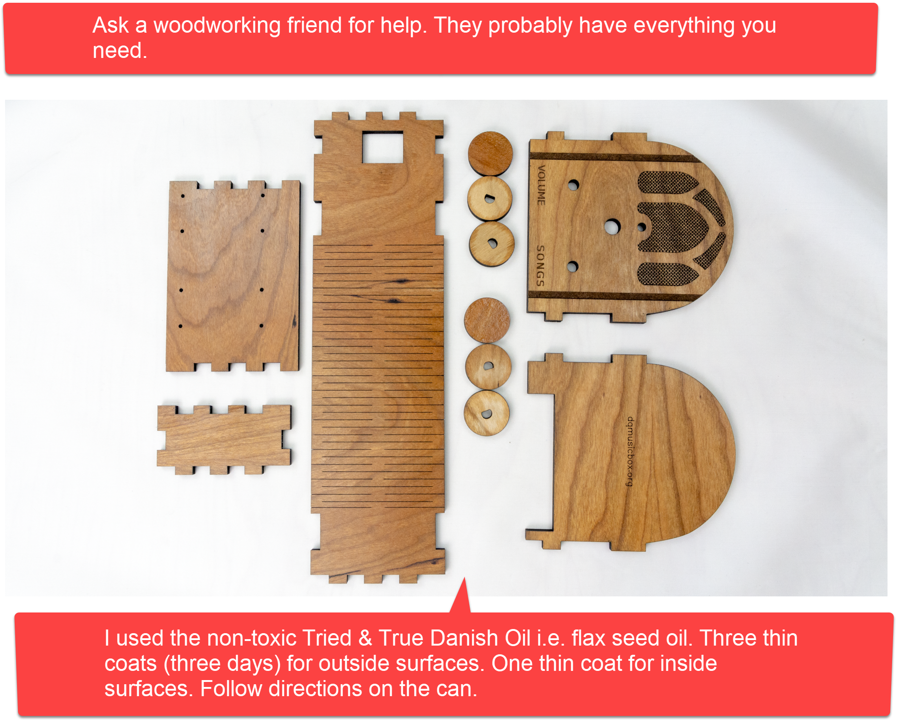

# STEP 5: Add the Pi

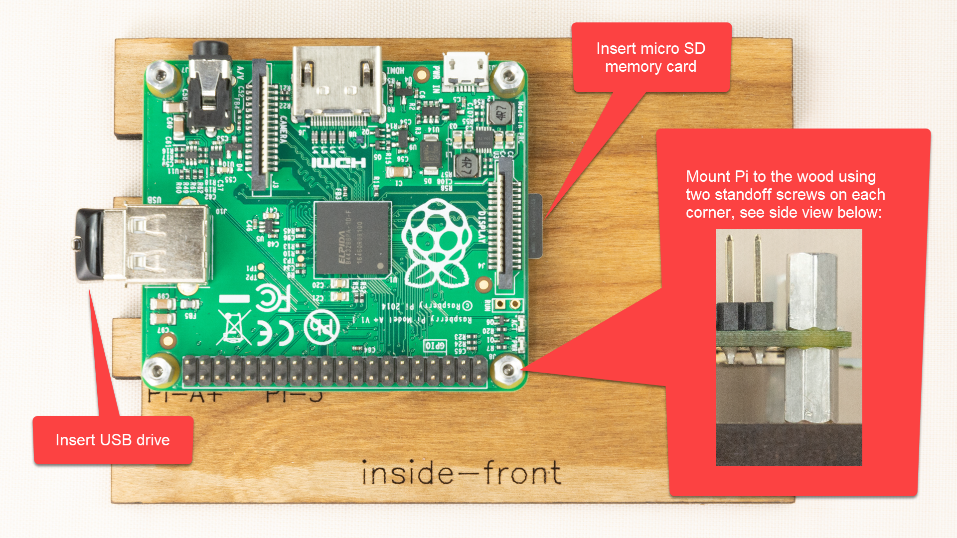

# STEP 6: Wire it

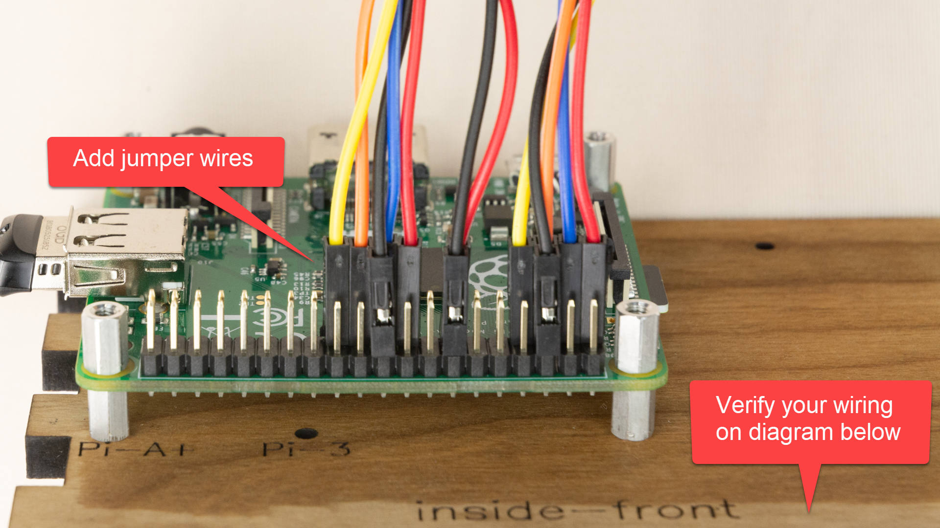



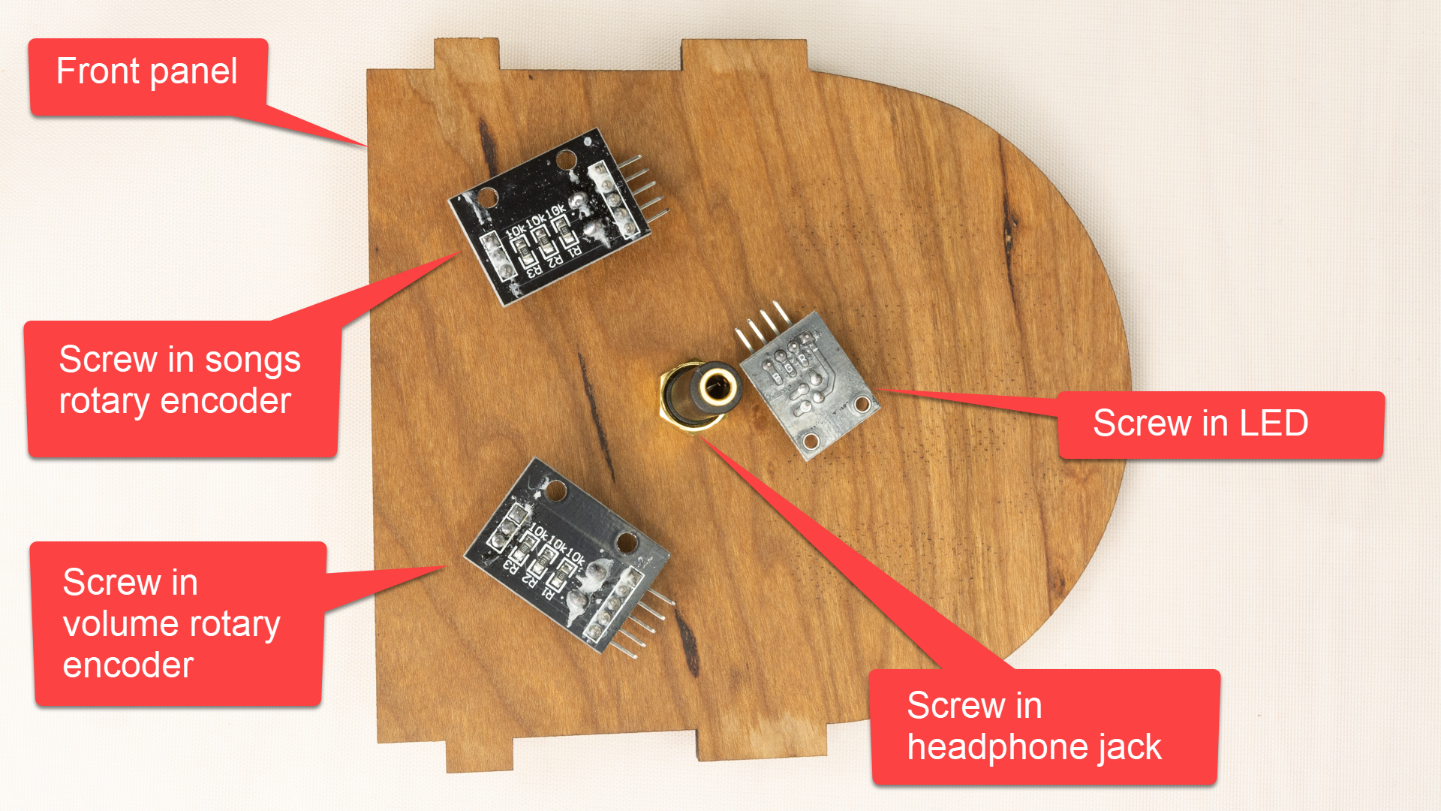

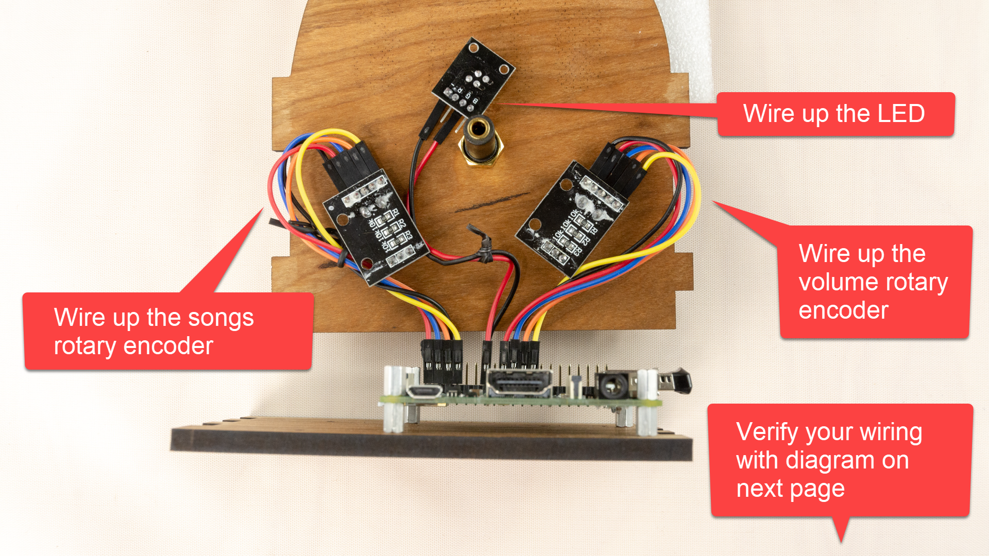



# STEP 7: Glue it

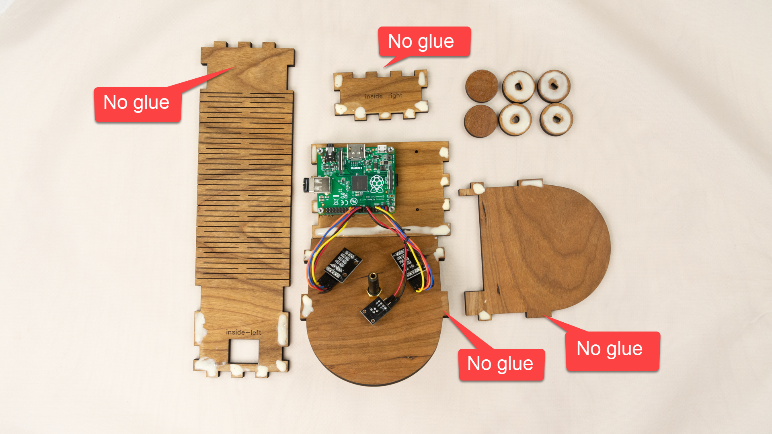

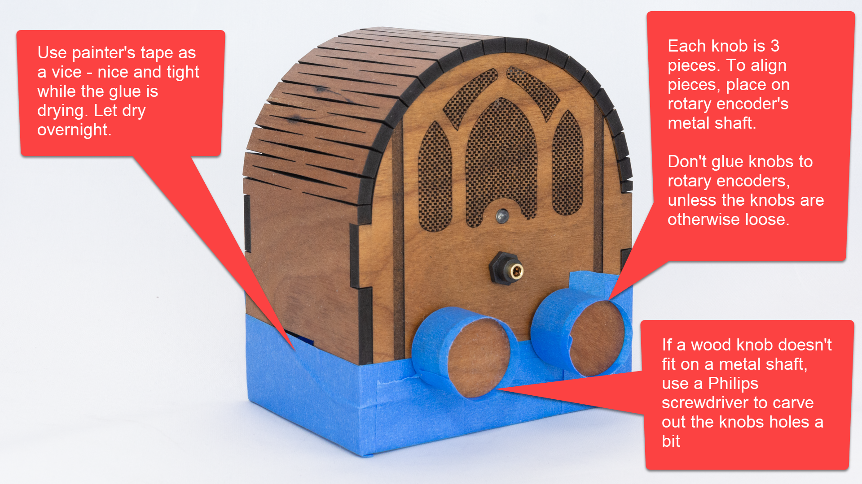

# STEP 8: Add audio cable

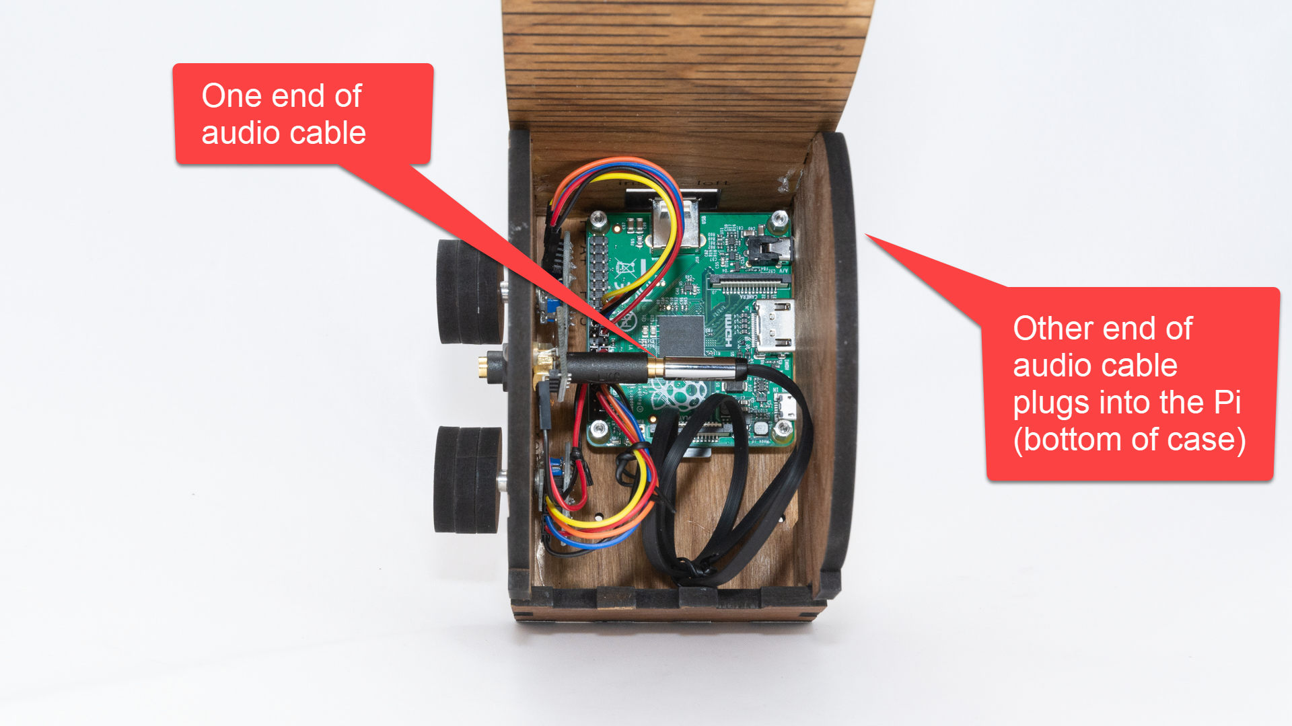

# Test it

|  |  |
| --- | --- |
| **Test** | **Description & Expectation** |
| Light 30sec after power on | The indicator LED turns on when DQMusicBox is ready to play music, which is generally 20-30 seconds after power on. |
| Start song | Turning either of the knobs will start music playing. |
| Change song | Turn the songs knob. If you go forward and backward through the song list as expected, then all is well. |
| Change volume | Turn the volume knob. If the volume goes up and down as expected, then all is well. |
| Pause | Tap the volume knob, song should pause. Tap the songs knob, this should also pause the song. |
| Unpause | Tap a knob |

## If one or both knows do the opposite of what you expect

Once assembled, you may find your knobs doing the opposite of what you expect e.g. a clockwise turn decreases the volume. This is because there are two kinds of rotary encoders out there. Happy, the fix is easy, just switch the orange and yellow wires on the misbehaving rotary encoders(s) (don’t touch the Pi itself):

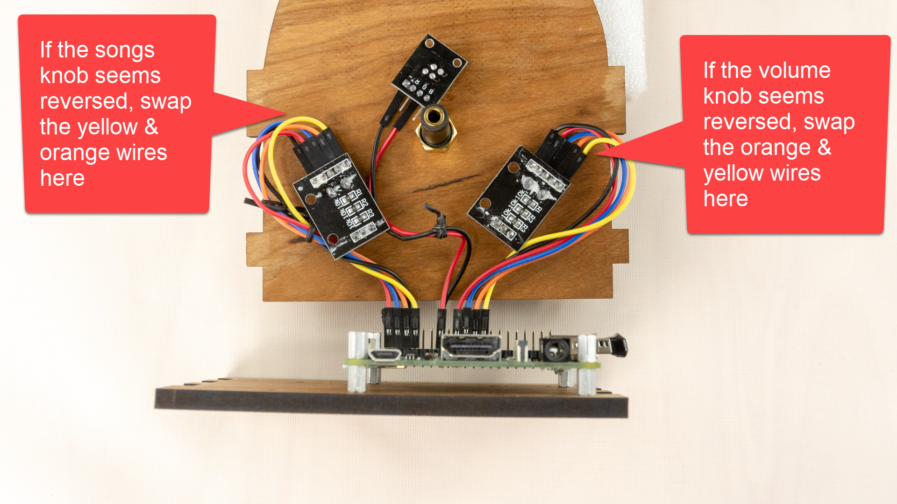

## If the wood knobs are loose on the metal shafts

Just glue the wood knobs to the metal shafts. But only if it is really necessary. Once the knobs & shafts are glued, it’s harder to dissemble the box to fix any problems.

## If the top does not latch securely

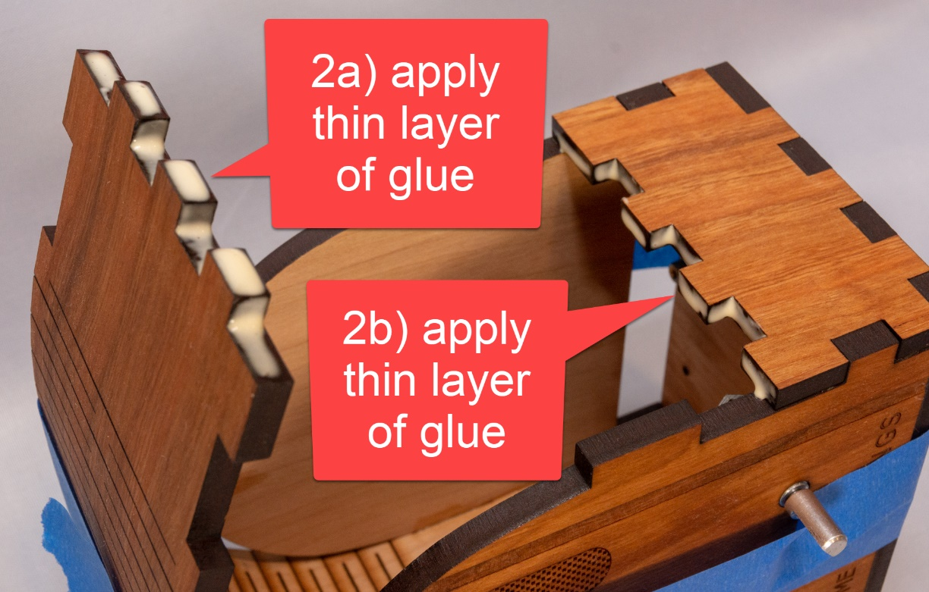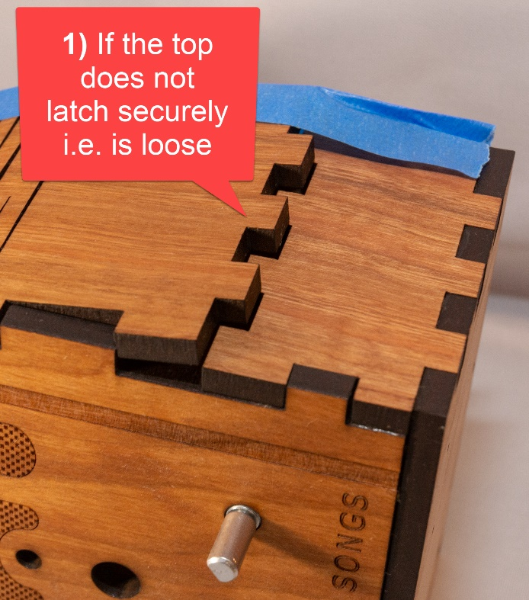To resolve, very slightly increase the size of the tabs by applying a thin layer of glue and allowing to dry before re-latching. It’s a friction latch, so you are essentially adding more static friction – slightly thicker tabs can mean much more static friction.



## Tape instructions

Print this page and tape the instructions in the box below to the bottom of your new DQMusicBox:

|  |
| --- |
| **To create personalized music**  **Organize the music on your computer**  One folder per album. Use MP3 files, must have .mp3 file extension. Or iTunes files (.m4a). Or FLAC files (.flac). Optionally, use folder names prefixes to specify the play order e.g. A_, B_  **Copy the music to the USB thumb drive**   1. https://images-na.ssl-images-amazon.com/images/I/71cTRglrgcL._SL1500_.jpgUnplug your DQMusicBox. 2. Remove the USB thumb drive and place in your computer. 3. Copy music files from your computer to the USB thumb drive. 4. Put the USB thumb drive back in the DQMusicBox. 5. Plug in your DQMusicBox. |

## Congratulations

Congratulations! You should have a fully functional DQMusicBox.

# Appendix 1: Change log

|  |  |
| --- | --- |
| v1, November 2015 | Original release |
| v2, September 2016 | * Changed music storage from a micro-SD memory card to a conventional USB memory stick. * Changed the base Operating System from full Raspbian to [DietPi](http://dietpi.com/) – much smaller, so faster to boot, and less to go wrong. |
| v3, January 2017 | * Changed from USB audio to Pi built-in audio, including a firmware update for excellent audio quality. |
| v4, May 2017 | * Switched to bamboo for durability and use of standoffs. * Switched to Pi A+ to lower cost. * Made USB thumb drive externally accessible, to make it easier for the caregiver to organize music. |
| v4.01, 25 June 2017 | * Minor edits. |
| v4.01_1, 20 July 2017 | * Minor edits. |
| v4.01_2, 11 August 2017 | * Added links for ordering parts in the UK. * Added detailed instructions for write protecting a micro-SD card. |
| v4.01_3, 12 August 2017 | * Minor edits |
| v4.01_4, 12 August 2017 | * Minor edits |
| v4.01_5, 14 October 2017 | * Edited text and updated photographs to reflect the change from an HDD-style LED to a KY-016 LED module. |
| v4.01_6, 26 February 2018 | * Updated the links for purchasing the parts. No changes to the parts themselves, just the links. * Minor change to the instructions, noting how the build can be accomplished in one sitting, if desired. |
| v4.1, 7 April 2018 | * Reflects that the software has been updated to support the new Raspberry Pi 3 B+. No new software features. |
| v4.1_1, 23 April 2018 | * Updated to reflect the new bamboo case design. |
| v4.1_2, 22 July 2018 | * Updated for the new cherry wood version |
| 27 Jan 2019 | * Updated to note support for the Raspberry Pi 3A+. |
| v4.2, 1 March 2019 | * Switched to pmount for USB drive auto mounting. |
| v4.2, 7 April 2018 | * Removed instructions for write protecting the SD card – rarely used and may cause certain rare problems |
| v4.2, 26 October 2019 | * Updated the parts list * Updated Ponoko instructions |
| v4.2, 28 October 2019 | * Updated Ponoko instructions |
| v4.2.1, 30 October 2019 | * Changed link to the new v4.2.1 of the software image * Noted support for Pi 4 * Updated Ponoko instructions to match Ponoko’s updated user interface |